TABLES

**Table 1.** Trial data for 23 trials conducted on post-release survival of spot prawns in the Broughton Archipelago, BC. Air temperature and salinity measurements were taken at the start of each trial set-up. Salinity was measured from the sea surface or, for trials XX-XX, from the seawater-filled tote that prawns were held in during trap hauling.

|  |  |  |  |  |  |  |  |  |  |  |  |
| --- | --- | --- | --- | --- | --- | --- | --- | --- | --- | --- | --- |
| **Trial**  **No.** | **Start-of-trial** | | | | | | | | **End-of-trial** | | |
|  |  |  | **Number of prawns** | | | | | | **Number of prawns** | | |
|  | **Air temp (oC)** | **Sal-inity (ppm)** | **‘Immediate’**  **release** | **30 min** | **60 min** | **90 min** | **120 min** | **Total** | **Total remaining** | **Lost** | **No band** |
| **1** | 12.9 | 31.2 | 80 | 76 | 81 | 80 | 0 | 317 | 274 | 43 | 44 |
| **2** | 12.9 | 29.9 | 37 | 55 | 55 | 55 | 0 | 202 | 188 | 14 | 24 |
| **3** | 15.2 | 30.4 | 40 | 78 | 79 | 82 | 0 | 279 | 257 | 22 | 26 |
| **4** | 10.7 | 31.3 | 60 | 60 | 63 | 60 | 0 | 243 | 215 | 28 | 22 |
| **5** | 13 | 28.6 | 40 | 40 | 40 | 40 | 0 | 160 | 153 | 7 | 10 |
| **6** | 14.1 | 31.3 | 36 | 36 | 35 | 35 | 0 | 142 | 104 | 38 | 4 |
| **7** | 14.3 | 31.4 | 50 | 50 | 50 | 50 | 50 | 250 | 209 | 41 | 17 |
| **8** | 12.8 | 30.3 | 70 | 70 | 70 | 70 | 0 | 280 | 285 | -5 | 14 |
| **9** | 13.6 | 26.2 | 39 | 39 | 39 | 39 | 0 | 156 | 117 | 39 | 9 |
| **10** | 15.5 | 30 | 54 | 54 | 54 | 54 | 54 | 270 | 201 | 69 | 24 |
| **11** |  |  |  |  |  |  |  |  |  |  |  |
| **12** |  |  |  |  |  |  |  |  |  |  |  |
| **13** | 12 | 24.5 | 56 | 56 | 56 | 56 | 0 | 224 | 212 | 12 | 6 |
| **14** | 12.3 | 26 | 30 | 30 | 30 | 30 | 0 | 120 | 108 | 12 | 3 |
| **15** | 11.9 | 27.5 | 70 | 70 | 70 | 70 | 70 | 350 | 295 | 55 | 3 |
| **16** | 13.5 | 30 | 70 | 70 | 70 | 70 | 70 | 350 | 348 | 2 | 15 |
| **17** | 14.3 | 29 | 60 | 60 | 60 | 60 | 60 | 300 | 272 | 28 | 11 |
| **18** | 11.5 | 25.6 | 70 | 69 | 70 | 70 | 70 | 349 | 344 | 5 | 12 |
| **19** | 17.8 | 25.1 | 70 | 70 | 70 | 70 | 70 | 350 | 309 | 41 | 7 |
| **20** | 25.7 | 25.4 | 70 | 70 | 70 | 70 | 70 | 350 | 345 | 5 | 10 |
| **21** | 22.2 | 24.7 | 44 | 44 | 44 | 44 | 0 | 176 | 176 | 0 | 5 |
| **22** | 25.4 | 25.4 | 70 | 70 | 70 | 70 | 70 | 350 | 343 | 7 | 4 |
| **23** | 18.7 | 25.9 | 60 | 60 | 60 | 60 | 60 | 300 | 297 | 3 | 3 |

**Table 2.** Statistics from generalised mixed-effects models fit to post-trial survival data for spot prawns. Models included combinations of three fixed effects: duration of air exposure (treatment), air temperature during exposure (temperature), and carapace length (length). All models included a random effect on the intercept for trial-trap number. Models with interaction terms include all lower-order effects and all models include an intercept term. Differences in BIC from the top model are listed under $∆$ BIC; $w_{i}$ indicates the model weight.

|  |  |  |  |  |
| --- | --- | --- | --- | --- |
| **Rank** | **Model** | $∆$**BIC** | $$w_{i}$$ | **Cumulative $w_{i}$** |
| 1 | Treatment x Temperature + Temperature x Length | 0 | 0.73 | 0.73 |
| 2 | Treatment x Temperature + Length | 2.4 | 0.22 | 0.95 |
| 3 | Treatment x Temperature | 6.4 | 0.03 | 0.98 |
| 4 | Treatment x Temperature + Treatment x Length + Temperature x Length | 8.1 | 0.01 | 0.99 |
| 5 | Treatment x Temperature + Treatment x Length | 9.1 | 0.01 | 1 |
| 6 | Temperature x Length + Treatment | 31.9 | 0 | 1 |
| 7 | Length + Treatment + Temperature | 32.4 | 0 | 1 |
| 8 | Treatment + Temperature | 37.5 | 0 | 1 |
| 9 | Treatment x Length + Temperature | 38.5 | 0 | 1 |
| 10 | Treatment x Length + Temperature x Length | 39.4 | 0 | 1 |
| 11 | Treatment + Length | 70.4 | 0 | 1 |
| 12 | Treatment x Length | 76.6 | 0 | 1 |
| 13 | Treatment | 77.4 | 0 | 1 |
| 14 | Temperature + Length | 1470.7 | 0 | 1 |
| 15 | Temperature | 1477.1 | 0 | 1 |
| 16 | Temperature x Length | 1477.7 | 0 | 1 |
| 17 | Length | 1508.1 | 0 | 1 |
| 18 | Null | 1516.3 | 0 | 1 |

**MAIN TEXT FIGURES**

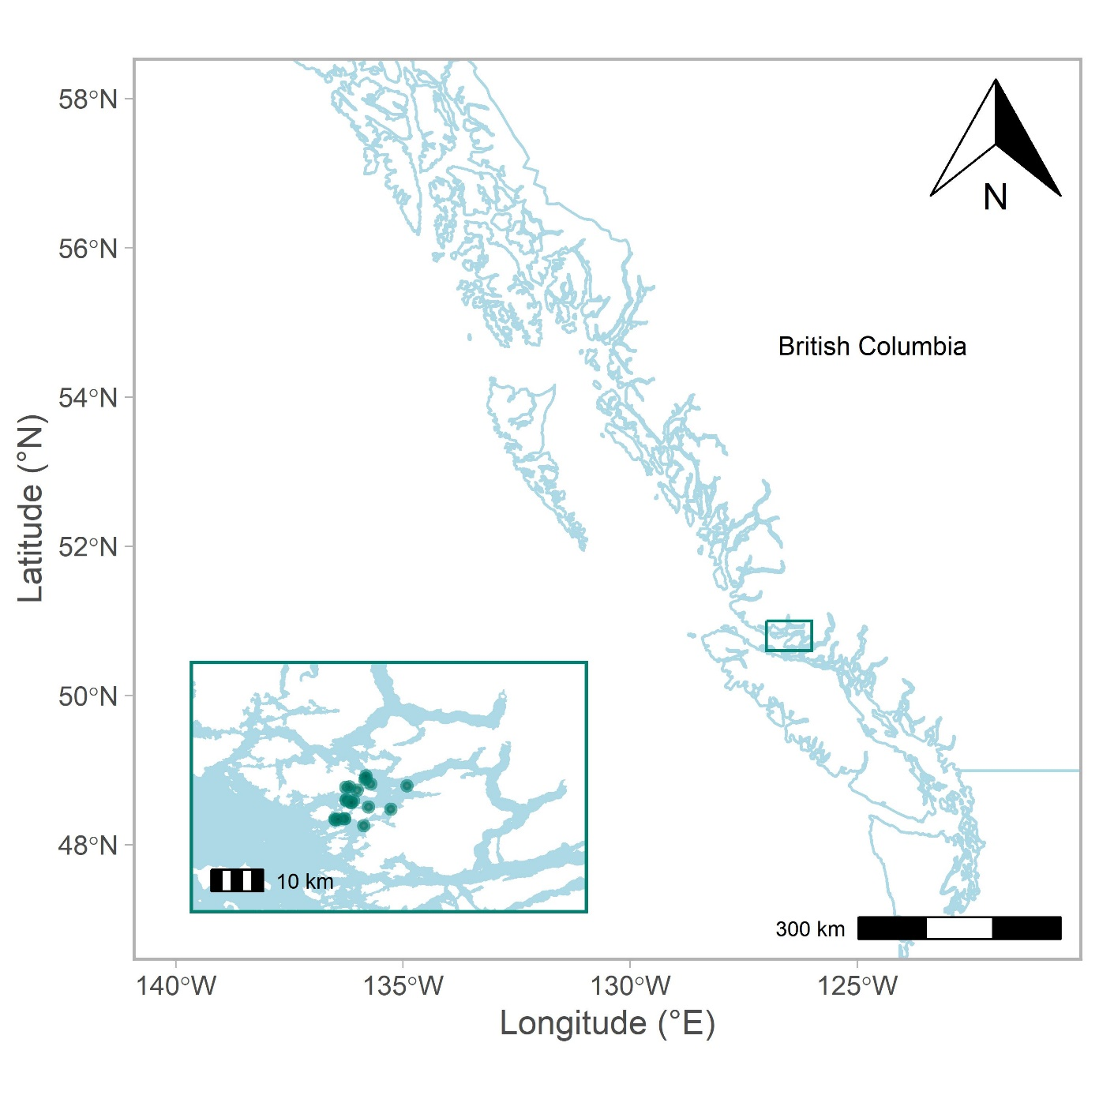

**Figure 1.** Map of study area in British Columbia off the northeast tip of Vancouver Island. Points reflect experimental set locations.

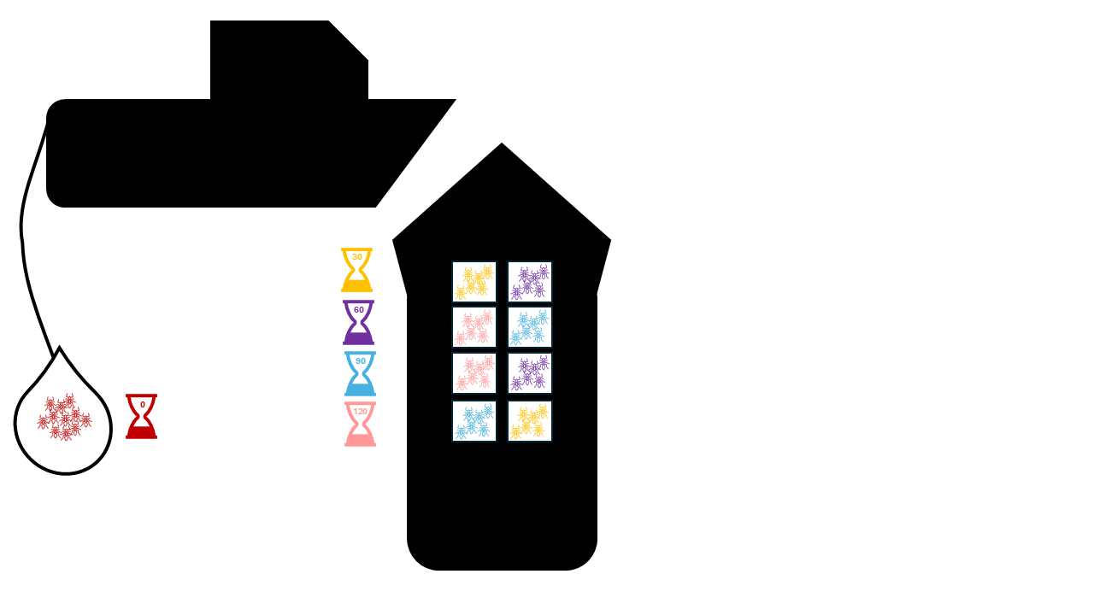

**Figure 2.** Schematic figure. [fill in caption]

**Figure 2.** Raw survival data (% prawns alive at end of trial) by air temperature (panel A) and time out of water (panel B). Each bar plot shows the mean trial-level percent survival for given temperature or treatment with bootstrapped 95% confidence intervals.

**Figure 4.** Length distributions of prawns at end of trial by survival (top panel) and by stage (bottom panel). Dashed line indicates minimum size threshold (33 mm) implemented in the commercial fishery.

**Figure 5.** Estimated post-24-hour mortality of prawns by treatment, based on relationship between reflexes and long-term mortality established by Stoner (2012).

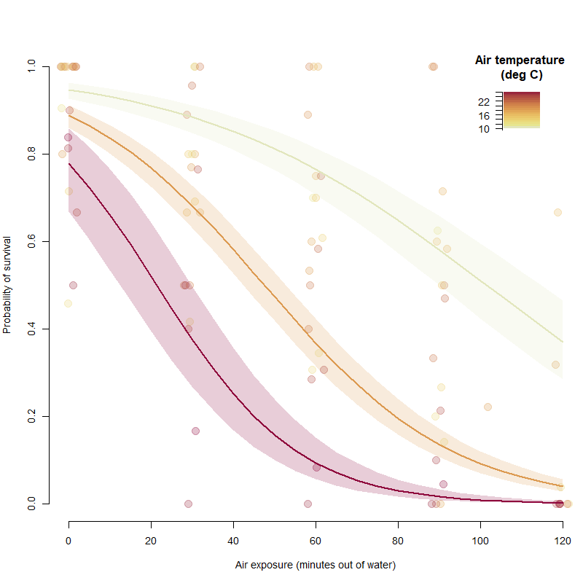

**Figure 5.** Estimated probability survival across varying periods of time out water (0-120 minutes) for three carapace lengths: 24 mm (top), 32 mm (middle), and 40 mm (bottom). Curves reflect model-predicted probability of survival across a range of air temperatures (11-23.5oC). Raw data points are visualised as bootstrapped means with 95% confidence intervals.

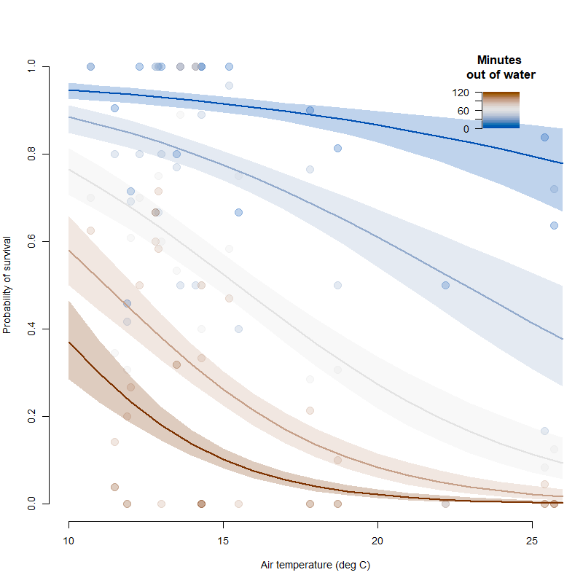

**Figure 6.** [insert caption]

**SUPPLEMENTARY FIGURES**

**Figure S1.** The per-trial number of unbanded prawns. These are prawns that lost the noseband denoting treatment and thus were not included in analysis. Decline in loss is likely due to improved banding technique as experiment progressed.

**Figure S2.** Number of prawns per trial by life stage.

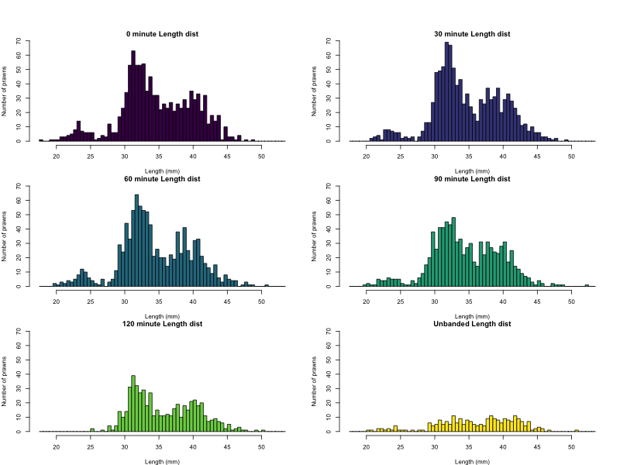

**Figure S3.** Length distribution of prawns per treatment and length distribution of unbanded prawns.

**Figure S4.** Number of lost prawns per trial. In this case, “lost” prawns include prawns that escaped trap and traps that lost their band. Note that in trial 8, we either miscounted the number of prawns that went down in the traps or a few prawns managed enter the trap resulting in more prawns at the end of the trial than at the start.

**Figure S5.** Proportion of prawns lost by treatment, where lost could be a prawn that lost its band or a prawn that was lost (escaped bag or trap) during the experiment. Each point reflects the proportional loss for one trial and bar reflects the mean across trials.

**Figure S6.** Trial-level distribution of prawn condition at the end of a trial. ‘Scavenged’ indicates prawns that were dead and also missing part of their body (e.g., appendages, etc). In some cases, we were not able to assess stage or accurately measure carapace length from scavenged prawns and these were excluded from the final analysis.